OAS Billing Notes October 2018
The October Billing Statements are being e-mailed to locations on October 16, 2018. If you are receiving this e-mail, you should also be receiving the statement from accountingservices@archindy.org (delivered by Intacct, the accounting system for the Archdiocese). If you do not receive the e-mail containing the October Billing Statement, please check your spam filter and junk folder. If you still cannot locate the Billing Statement, please reach out to us at accountingservices@archindy.org.

The e-mail containing the Billing Statement looks as follows:
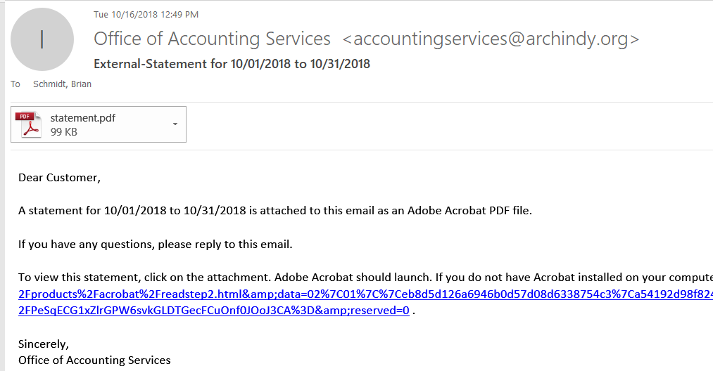
The October Billing Statement includes the following items, among others:
Insurance Premiums
Lay Health Insurance Premiums. The lay health insurance premiums billed on the October statement are for September coverage for both medical and dental insurance. To understand how your location’s charge was calculated, refer to the “Instructions - Employee Listing for Lay Health Insurance Employer Charges” and “Lay Health Insurance Calculation and Reconciliation to Billing Statement” files (separate attachments). These files contain instructions for running the Paylocity Deduction Listing Report for September pay dates and recalculating the employer lay health insurance premiums. These files are also included on the website at http://www.archindy.org/finance/parish/newsletter.html if you are unable to open the attachments in this Flocknote e-mail.
Property Insurance Premiums and Vehicle Insurance Premiums. Property insurance and vehicle insurance premiums are billed based on properties and vehicles held as of July 1, 2018. This amount will remain fixed for the duration of the fiscal year.
Workers Compensation (WC) Insurance Premiums. Workers compensation insurance premiums are billed based on the wages incurred for the previous calendar year (1/1/2017 to 12/31/2017). This amount will remain fixed for the duration of the fiscal year.

Assessments
The Parish and School Budget Guidelines on the archindy.org/finance website contain information about budgeted Billing and Assessments, as well as a calendar of when various charges will be billed throughout the course of the fiscal year. Each location’s assessments (other than deanery assessments) are included in Appendix C – Assessment Workbook (embedded Excel file within the Word document Budget Guidelines). These assessments are all billed evenly over the 12 months of the fiscal year.
Cathedraticum Assessment.
Lay Retirement Assessment.
Clergy Healthcare Assessment
Indy Education Assessment
Latino Outreach Assessment
Deanery Assessments

Wages and Compensation
Wages and Stipends. There were two pay dates in September; September 14th and September 28th. Priest wages, mass stipends, billable lay wages, and non-mass stipends for those pay dates are included on the October Billing Statement.

Other Charges
Criterion Subscriptions. All parishes are billed at an annual rate of $16 per household ($1.33 per household per month) for subscription to the Criterion newspaper, based on the number of households as of May 31, 2018. This amount will remain fixed for the duration of the fiscal year.
Archdiocesan Purchasing Department (APD) Purchases. For APD purchases in September, we have included as much detail about the purchase as we can on the Billing Statement. If you have specific questions about APD charges, please contact Steve James, Archdiocesan Purchasing Manager, at sjames@archindy.org or 317-236-1451.
Fees for the 3rd Annual Gathering of Disciples, hosted by the Office of Catechesis.
Renaissance Learning Fees for 2018-19 (Office of Catholic Schools).
We anticipate doing the bill pull on the last business day of the month: Wednesday, October 31st.
Please contact the Office of Accounting Services at accountingservices@archindy.org or 317-236-1410 if you have questions about the October Billing Statement.

